Assignment 2

Submitted by,

M.SHINY,

ECE

961819106047

**1)Create User table with email, username, roll number, password:**

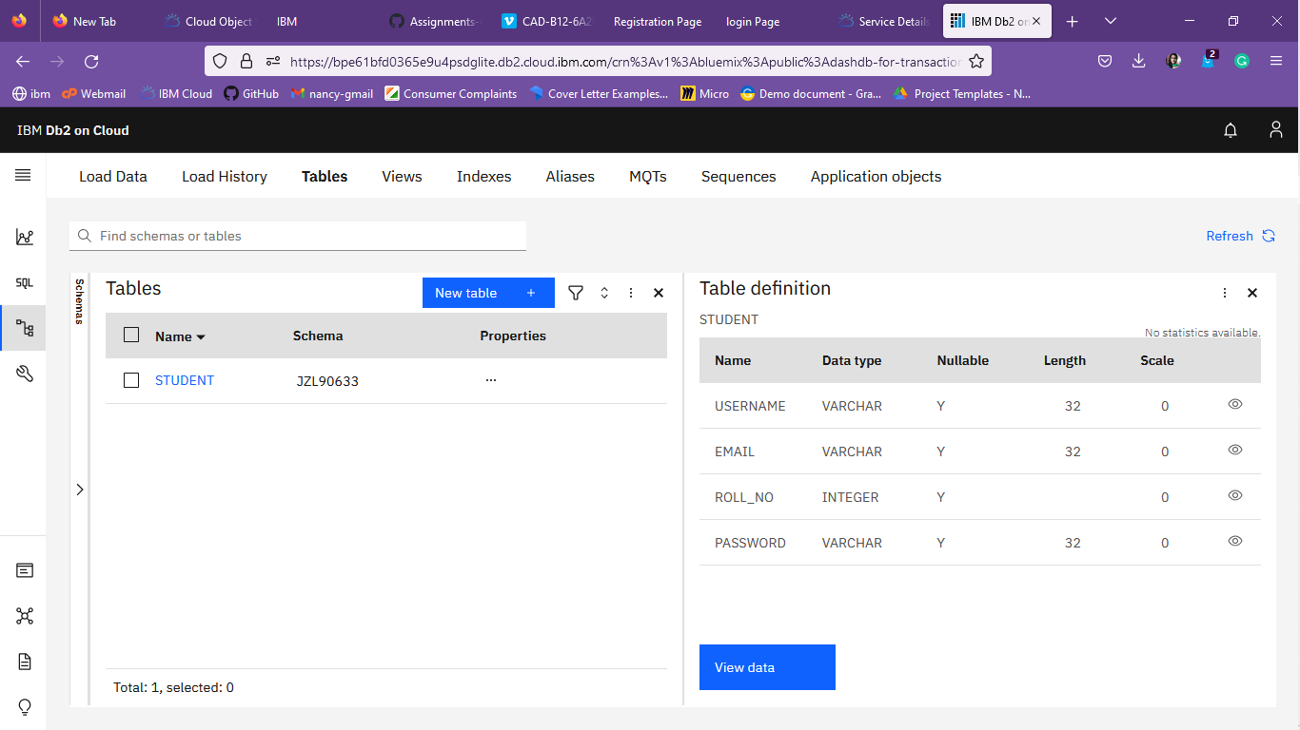

**2)Perform UPDATE, DELETE Queries with user table:**

**i) INSERT**

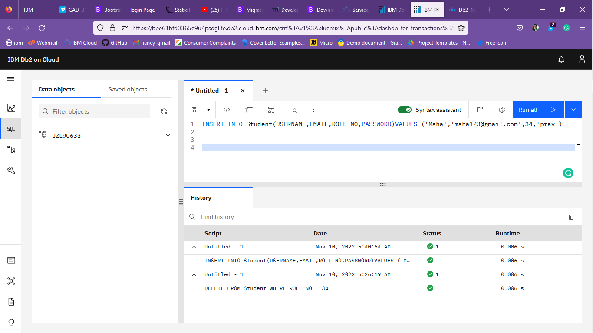

**ii)DELETE**

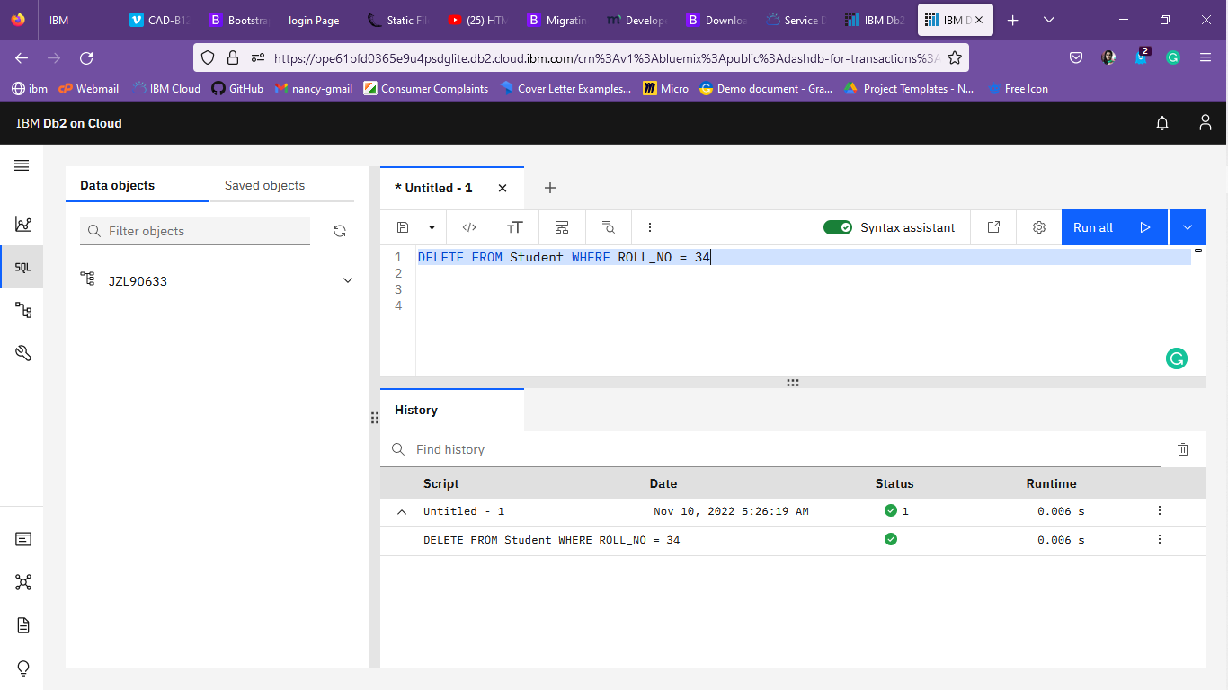

**iii)UPDATE**

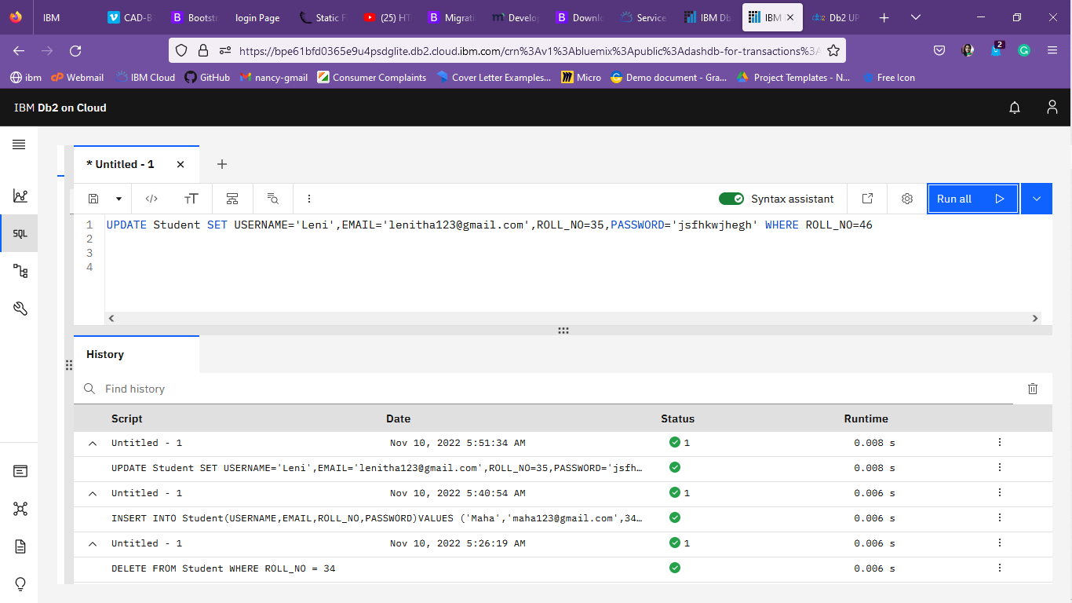

**3)Connect python code to db2:**

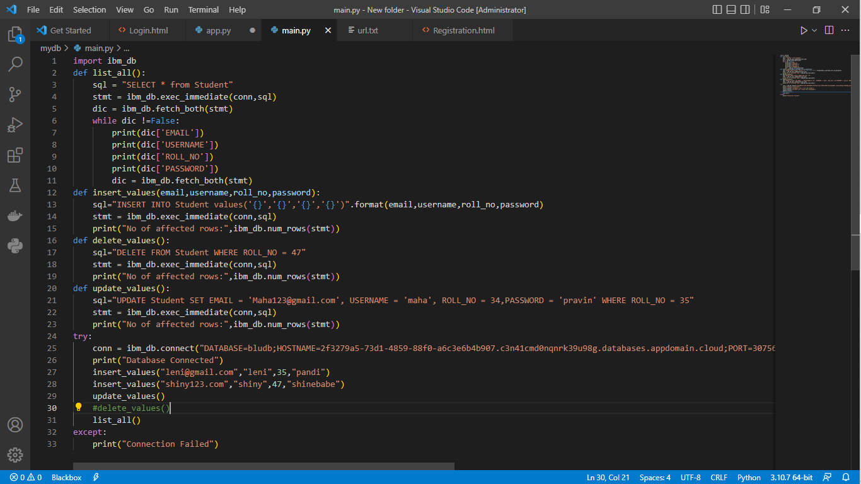

**4)Create a flask app with registration page, login page and welcome page. By default, load the registration page once the user enters all the fields store the data in database and navigate to login page. Authenticate user with username and password. If the user is valid show the welcome page:**

**i)Registration Page**

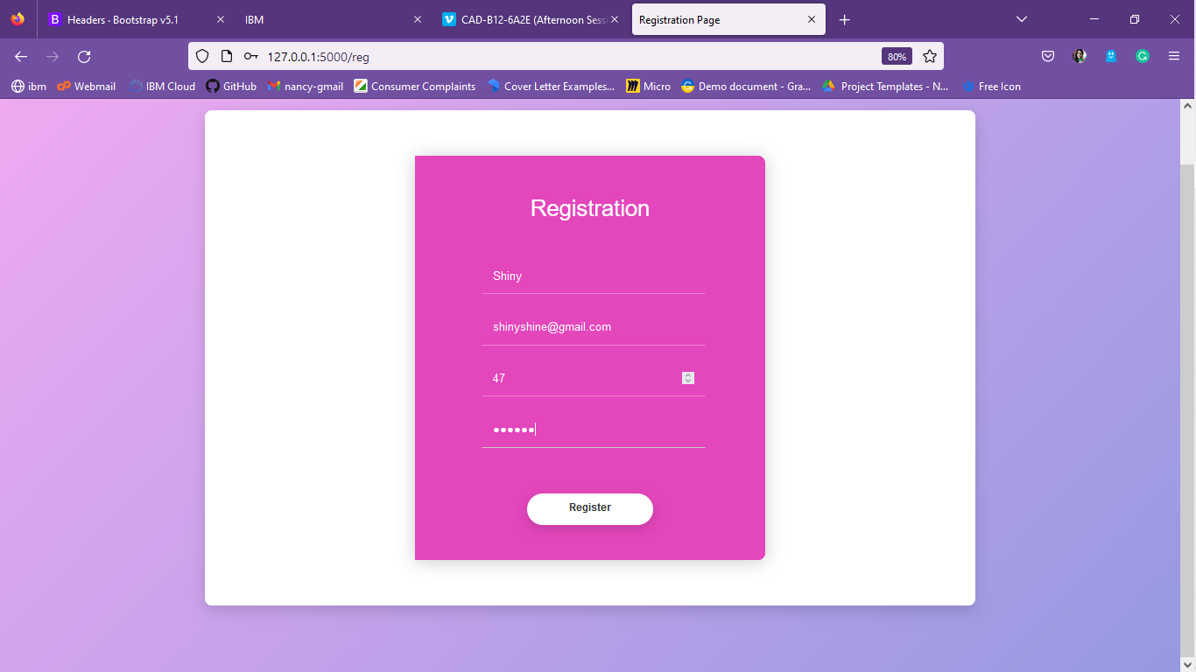

**ii)Login Page**

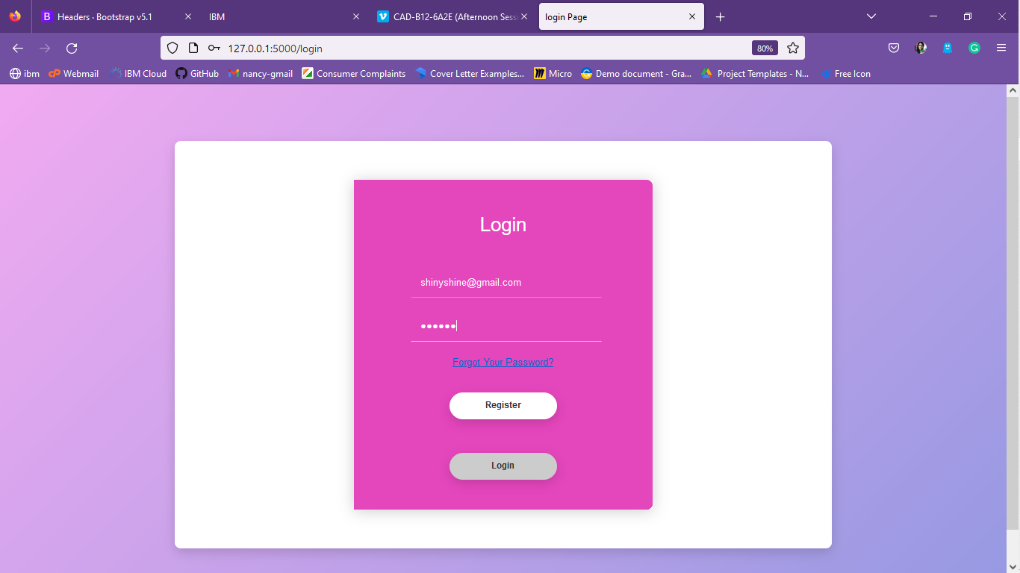

**iii)Welcome Page**

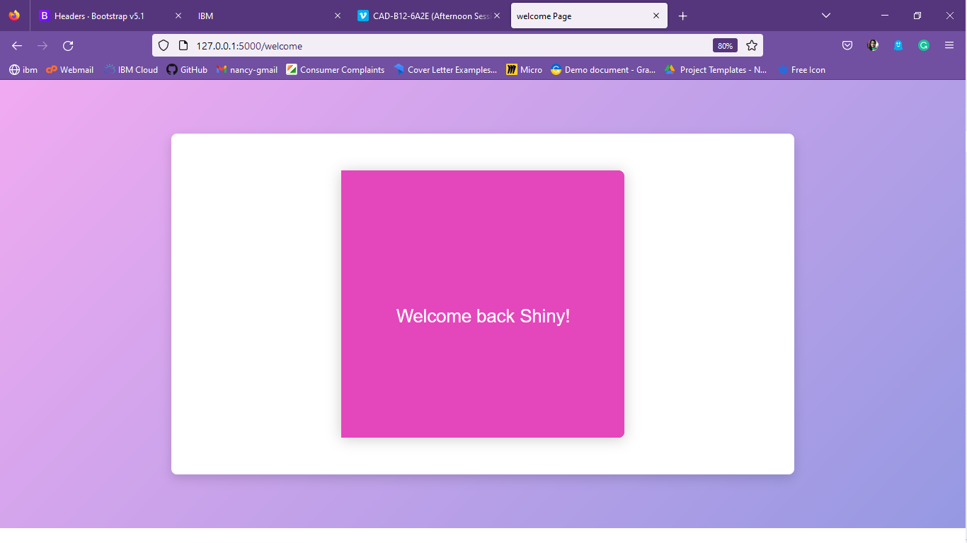

**HTML Templates:**

Registration Page:

<!DOCTYPE html>

<html>

    <head>

        <title>Registration Page</title>

        <meta charset="utf-8">

        <!-- Mobile Specific Metas -->

        <meta name="viewport" content="width=device-width, initial-scale=1, maximum-scale=1">

        <!-- Font-->

        <link rel="stylesheet"  href="static/montserrat-font.css">

        <link rel="stylesheet"  href="static/material-design-iconic-font.min.css">

        <!-- Main Style Css -->

        <link rel="stylesheet" href="static/style.css">

    </head>

    <body class="form-v10">

      <div class="page-content">

        <div class="form-v10-content">

          <form class="form-detail" action="#" method="post" id="myform">

            <div class="login-form">

              <div class="form-right">

                <div class="form-rightn">

                  <form>

                    <h1 >Registration</h1>

                    <div class="content">

                      <div class="form-row form-row-2">

              <input type="text" name="username" id="username" class="input-text" placeholder="User Name" required>

            </div>

            <div class="form-row form-row-3">

                          <input type="email" name="email" class="email" id="email" placeholder="Email" required>

                        </div>

            <div class="form-row form-row-2">

              <input type="number" name="rollno" id="rollno" class="input-text" placeholder="Roll No" required>

            </div>

                        <div class="form-row form-row-4">

                          <input type="password" name="password" class="password" id="password" placeholder="password" required autocomplete="new-password">

                        </div>

                    </div>

                    <div class="form-row-lastn">

                      <input type=button name="register" class="register" value="Register">

                    </div>

                  </form>

                </div>

              </div>

          </form>

        </div>

      </div>

    </body>

</html>

Login Page:

<!DOCTYPE html>

<html>

    <head>

        <title>login Page</title>

        <meta charset="utf-8">

        <!-- Mobile Specific Metas -->

        <meta name="viewport" content="width=device-width, initial-scale=1, maximum-scale=1">

        <!-- Font-->

        <link rel="stylesheet"  href="static/montserrat-font.css">

        <link rel="stylesheet"  href="static/material-design-iconic-font.min.css">

        <!-- Main Style Css -->

        <link rel="stylesheet" href="static/style.css">

    </head>

    <body class="form-v10">

      <div class="page-content">

        <div class="form-v10-content">

          <form class="form-detail">

            <div class="login-form">

              <div class="form-right">

                <div class="form-rightn">

                  <form action="/receivedata" method="post" id="myform">

                    <h1 >Login</h1>

                    <div class="content">

                      <div class="form-row form-row-3">

                        <input type="email" name="email" class="email" id="email" placeholder="Email" required>

                        </div>

                        <div class="form-row form-row-4">

                          <input type="password" name="password" class="password" id="password" placeholder="password" required autocomplete="new-password">

                      </div>

                      <a href="#" class="link">Forgot Your Password?</a>

                    </div>

                    <div class="form-row-lastn">

                      <input type=button name="register" class="register" value="Register">

                    </div>

                    <div class="form-row-lastn">

                      <input type=button name="action" class="register" value="Login">

                    </div>

                  </form>

                </div>

              </div>

          </form>

        </div>

      </div>

    </body>

</html>

Welcome Page:

<!DOCTYPE html>

<html>

    <head>

        <title>welcome Page</title>

        <meta charset="utf-8">

        <!-- Mobile Specific Metas -->

        <meta name="viewport" content="width=device-width, initial-scale=1, maximum-scale=1">

        <!-- Font-->

        <link rel="stylesheet"  href="static/montserrat-font.css">

        <link rel="stylesheet"  href="static/material-design-iconic-font.min.css">

        <!-- Main Style Css -->

        <link rel="stylesheet" href="static/style.css">

    </head>

    <body class="form-v10">

      <div class="page-content">

        <div class="form-v10-content">

          <form class="form-detail" action="#" method="post" id="myform">

            <div class="login-form">

              <div class="form-right">

                <div class="form-rightn">

                    <form>

                    <h1 ></h1>

                    <div class="content">

                        <p1>

                        </p1>

                    </div>

                    <div class="content">

                      <h1> Welcome back Shiny!

                      </h1>

                    </div>

                    <div class="content">

                        <p1>

                        </p1>

                    </div>

                    <div class="content">

                      <p1>

                      </p1>

                  </div>

                    </form>

                </div>

              </div>

          </form>

        </div>

      </div>

    </body>

</html>

**Static:**

style.css:

body {

    margin:  0;

}

.button{

    padding-left: 0;

    text-align: center;

    margin: 44px 0 30px;}

.login-form {

  background: #fff;

  width: 500px;

  margin: 65px auto;

  display: -webkit-box;

  display: flex;

  -webkit-box-orient: vertical;

  -webkit-box-direction: normal;

          flex-direction: column;

  border-radius: 4px;

  box-shadow: 0 2px 25px rgba(0, 0, 0, 0.2);

  text-align: center;

}

.login-form h1 {

  padding: 35px 35px 0 35px;

  font-weight: 300;

  text-align: center;

  color: #fff;

}

.login-form .content {

  padding: 35px;

  text-align: center;

  text-align: center;

}

.page-content {

    width: 100%;

    margin:  0 auto;

    background: #75e2e9;

    display: flex;

    display: -webkit-flex;

    justify-content: center;

    -o-justify-content: center;

    -ms-justify-content: center;

    -moz-justify-content: center;

    -webkit-justify-content: center;

    align-items: center;

    -o-align-items: center;

    -ms-align-items: center;

    -moz-align-items: center;

    -webkit-align-items: center;

    background-image: -moz-linear-gradient( 136deg, rgb(149,153,226) 0%, rgb(241, 170, 241) 100%);

    background-image: -webkit-linear-gradient( 136deg, rgb(149,153,226) 0%, rgb(241, 170, 241) 100%);

    background-image: -ms-linear-gradient( 136deg, rgb(149,153,226) 0%, rgb(241, 170, 241) 100%);

}

.form-v10-content  {

    background: #fff;

    width: 1100px;

    border-radius: 10px;

    -o-border-radius: 10px;

    -ms-border-radius: 10px;

    -moz-border-radius: 10px;

    -webkit-border-radius: 10px;

    box-shadow: 0px 8px 20px 0px rgba(0, 0, 0, 0.15);

    -o-box-shadow: 0px 8px 20px 0px rgba(0, 0, 0, 0.15);

    -ms-box-shadow: 0px 8px 20px 0px rgba(0, 0, 0, 0.15);

    -moz-box-shadow: 0px 8px 20px 0px rgba(0, 0, 0, 0.15);

    -webkit-box-shadow: 0px 8px 20px 0px rgba(0, 0, 0, 0.15);

    margin: 95px 0;

    position: relative;

    font-family: 'Montserrat', sans-serif;

}

.form-v10-content .form-detail {

    position: relative;

    width: 100%;

    display: flex;

    display: -webkit-flex;

}

.form-v10-content .form-detail h2 {

    font-weight: 500;

    font-size: 25px;

    margin-bottom: 34px;

    padding: 33px 50px 0px 60px;

}

.form-v10-content .form-detail .form-left {

    border-top-left-radius: 10px;

    border-bottom-left-radius: 10px;

    width: 100%;

}

.form-v10-content .form-detail .form-left h2 {

    color: #e446bc;

}

.form-v10-content .form-detail .form-right {

    width: 100%;

    background: #e446bc;

    border-top-right-radius: 10px;

    border-bottom-right-radius: 10px;

}

.form-v10-content .form-detail .form-rightn {

    width: 100%;

    background: #e446bc;

    border-top-right-radius: 10px;

    border-bottom-right-radius: 10px;

    border-top-left-radius: 10px;

    border-bottom-left-radius:10px;

    align-items: center;

}

.form-v10-content .form-detail .form-right h2 {

    color: #fff;

}

.form-v10-content .form-detail .form-group {

    display: flex;

    display: -webkit-flex;

}

.form-v10-content .form-detail .form-row {

    position: relative;

    margin-bottom: 24px;

    padding-left: 60px;

    padding-right: 50px;

}

.form-v10-content .form-detail .form-row {

    position: relative;

    margin-bottom: 24px;

    padding-left: 60px;

    padding-right: 50px;

}

.form-v10-content .form-detail .form-left .form-group .form-row.form-row-1 {

    width: 50%;

    padding: 0 12px 0 60px;

}

.form-v10-content .form-detail .form-left .form-group .form-row.form-row-2 {

    width: 50%;

    padding: 0 50px 0 12px;

}

.form-v10-content .form-detail .form-left .form-group .form-row.form-row-3 {

    width: 73%;

    padding: 0 12px 0 60px;

}

.form-v10-content .form-detail .form-left .form-group .form-row.form-row-4 {

    width: 50%;

    padding: 0 50px 0 12px;

}

.form-v10-content .form-detail .form-right .form-group .form-row.form-row-1 {

    width: 50%;

    padding: 0 12px 0 60px;

}

.form-v10-content .form-detail .form-right .form-group .form-row.form-row-2 {

    width: 100%;

    padding: 0 50px 0 12px;

}

.form-v10-content .form-detail select,

.form-v10-content .form-detail input {

    width: 100%;

    padding: 11.5px 15px 15px 15px;

    border: 1px solid transparent;

    background: transparent;

    appearance: unset;

    -moz-appearance: unset;

    -webkit-appearance: unset;

    -o-appearance: unset;

    -ms-appearance: unset;

    outline: none;

    -moz-outline: none;

    -webkit-outline: none;

    -o-outline: none;

    -ms-outline: none;

    font-family: 'Montserrat', sans-serif;

    font-size: 16px;

    box-sizing: border-box;

    -moz-box-sizing: border-box;

    -webkit-box-sizing: border-box;

    -o-box-sizing: border-box;

    -ms-box-sizing: border-box;

}

.form-v10-content .form-detail select {

    background: 0 0;

    position: relative;

    z-index: 9;

    cursor: pointer;

}

.form-v10-content .form-detail .form-left select {

    color: #666;

}

.form-v10-content .form-detail .form-right select {

    color: rgb(255, 255, 255);

}

.form-v10-content .form-detail .select-btn {

    z-index: 0;

    position: absolute;

    top: 30%;

    right: 11.5%;

    font-size: 18px;

}

.form-v10-content .form-detail .form-left .select-btn {

    color: #666;

}

.form-v10-content .form-detail .form-right .select-btn {

    color: #f2f2f2;

}

.form-v10-content .form-detail .form-group .form-row.form-row-4 .select-btn {

    top: 20%;

    right: 26%;

}

.form-v10-content .form-detail .form-right .form-group .form-row.form-row-2 .select-btn {

    top: 20%;

    right: 19%;

}

.form-v10-content .form-detail .form-left input {

    color: #000;

}

.form-v10-content .form-detail .form-right input {

    color: #fff;

}

.form-v10-content .form-detail .form-left input,

.form-v10-content .form-detail .form-left select {

    border-bottom: 1px solid #ccc;

}

.form-v10-content .form-detail .form-left input:focus,

.form-v10-content .form-detail .form-left select:focus {

    border-bottom: 1px solid #999;

}

.form-v10-content .form-detail .form-right input,

.form-v10-content .form-detail .form-right select {

    border-bottom: 1px solid;

    border-bottom-color: rgba(255, 255, 255, 0.3);

}

.form-v10-content .form-detail .form-right input:focus,

.form-v10-content .form-detail .form-right select:focus {

    border-bottom: 1px solid #ccc;

}

.form-v10-content .form-detail .form-right select option {

    background: #ccc;

}

.form-v10-content .form-detail .form-checkbox {

    margin-top: 37px;

    padding: 0 50px 0 60px;

    position: relative;

}

.form-v10-content .form-detail .form-checkbox input {

    position: absolute;

    opacity: 0;

}

.form-v10-content .form-detail .form-checkbox .checkmark {

    position: absolute;

    top: 1px;

    left: 60px;

    height: 15px;

    width: 15px;

    border: 1px solid #e5e5e5;

    cursor: pointer;

}

.form-v10-content .form-detail .form-checkbox .checkmark::after {

    content: "";

    position: absolute;

    left: 5px;

    top: 1px;

    width: 3px;

    height: 8px;

    border: 1px solid #fff;

    border-width: 0 2px 2px 0;

    -webkit-transform: rotate(45deg);

    -ms-transform: rotate(45deg);

    -o-transform: rotate(45deg);

    -moz-transform: rotate(45deg);

    transform: rotate(45deg);

    display: none;

}

.form-v10-content .form-detail .form-checkbox input:checked ~ .checkmark::after {

    display: block;

}

.form-v10-content .form-detail .form-checkbox p {

    margin-left: 34px;

    color: #e5e5e5;

    font-size: 14px;

    font-weight: 400;

}

.form-v10-content .form-detail .form-checkbox .text {

    font-weight: 400;

    color: #fff;

    text-decoration: underline;

}

.form-v10-content .form-detail .form-right .form-row-last {

    padding-left: 60px;

    margin: 44px 0 10px;

}

.form-v10-content .form-detail .form-right .form-row-lastn {

    align-items: center;

}

.form-v10-content .form-detail .form-right .register {

    background: #fff;

    border-radius: 25px;

    -o-border-radius: 25px;

    -ms-border-radius: 25px;

    -moz-border-radius: 25px;

    -webkit-border-radius: 25px;

    box-shadow: 0px 6px 17px 0px rgba(0, 0, 0, 0.15);

    -o-box-shadow: 0px 6px 17px 0px rgba(0, 0, 0, 0.15);

    -ms-box-shadow: 0px 6px 17px 0px rgba(0, 0, 0, 0.15);

    -moz-box-shadow: 0px 6px 17px 0px rgba(0, 0, 0, 0.15);

    -webkit-box-shadow: 0px 6px 17px 0px rgba(0, 0, 0, 0.15);

    width: 180px;

    border: none;

    margin: 6px 0 50px 0px;

    cursor: pointer;

    color: #333;

    font-weight: 700;

    font-size: 15px;

}

.form-v10-content .form-detail .form-right .register:hover {

    background: #ccc;

}

.form-v10-content .form-detail .form-right .form-row-last input {

    padding: 12.5px;

}

.form-v10-content .form-detail .form-right .form-row-lastn input {align-items: center;

}

.form-v10-content .form-detail .form-left input::-webkit-input-placeholder { /* Chrome/Opera/Safari */

  color: #666;

  font-size: 16px;

}

.form-v10-content .form-detail .form-left input::-moz-placeholder { /* Firefox 19+ */

  color: #666;

  font-size: 16px;

}

.form-v10-content .form-detail .form-left input:-ms-input-placeholder { /* IE 10+ */

  color: #666;

  font-size: 16px;

}

.form-v10-content .form-detail .form-left input:-moz-placeholder { /* Firefox 18- */

  color: #666;

  font-size: 16px;

}

.form-v10-content .form-detail .form-right input::-webkit-input-placeholder { /* Chrome/Opera/Safari */

  color: #f2f2f2;

  font-size: 16px;

}

.form-v10-content .form-detail .form-right input::-moz-placeholder { /* Firefox 19+ */

  color: #f2f2f2;

  font-size: 16px;

}

.form-v10-content .form-detail .form-right input:-ms-input-placeholder { /* IE 10+ */

  color: #f2f2f2;

  font-size: 16px;

}

.form-v10-content .form-detail .form-right input:-moz-placeholder { /* Firefox 18- */

  color: #f2f2f2;

  font-size: 16px;

}

/* Responsive */

@media screen and (max-width: 1199px) {

    .form-v10-content {

        margin:  95px 20px;

    }

}

@media screen and (max-width: 991px) and (min-width: 768px) {

    .form-v10-content .form-detail .form-group {

        flex-direction:  column;

        -o-flex-direction:  column;

        -ms-flex-direction:  column;

        -moz-flex-direction:  column;

        -webkit-flex-direction:  column;

    }

    .form-v10-content .form-detail .form-left .form-group .form-row.form-row-1,

    .form-v10-content .form-detail .form-left .form-group .form-row.form-row-2,

    .form-v10-content .form-detail .form-left .form-group .form-row.form-row-3,

    .form-v10-content .form-detail .form-left .form-group .form-row.form-row-4,

    .form-v10-content .form-detail .form-right .form-group .form-row.form-row-1,

    .form-v10-content .form-detail .form-right .form-group .form-row.form-row-2 {

        width: auto;

        padding: 0 50px 0 60px;

    }

    .form-v10-content .form-detail .select-btn,

    .form-v10-content .form-detail .form-left .form-group .form-row.form-row-4 .select-btn,

    .form-v10-content .form-detail .form-right .form-group .form-row.form-row-2 .select-btn {

        right: 15%;

    }

}

@media screen and (max-width: 767px) {

    .form-v10-content .form-detail {

        flex-direction:  column;

        -o-flex-direction:  column;

        -ms-flex-direction:  column;

        -moz-flex-direction:  column;

        -webkit-flex-direction:  column;

    }

    .form-v10-content .form-detail .form-right {

        border-top-right-radius: 0px;

        border-bottom-left-radius: 10px;

    }

    .form-v10-content .form-detail .form-left {

        padding-bottom: 50px;

    }

}

@media screen and (max-width: 575px) {

    .form-v10-content .form-detail .form-group {

        flex-direction:  column;

        -o-flex-direction:  column;

        -ms-flex-direction:  column;

        -moz-flex-direction:  column;

        -webkit-flex-direction:  column;

    }

    .form-v10-content .form-detail .form-row,

    .form-v10-content .form-detail .form-left .form-group .form-row.form-row-1,

    .form-v10-content .form-detail .form-left .form-group .form-row.form-row-2,

    .form-v10-content .form-detail .form-left .form-group .form-row.form-row-3,

    .form-v10-content .form-detail .form-left .form-group .form-row.form-row-4,

    .form-v10-content .form-detail .form-right .form-group .form-row.form-row-1,

    .form-v10-content .form-detail .form-right .form-group .form-row.form-row-2 {

        width: auto;

        padding: 0 30px;

    }

    .form-v10-content .form-detail .select-btn,

    .form-v10-content .form-detail .form-left .form-group .form-row.form-row-4 .select-btn,

    .form-v10-content .form-detail .form-right .form-group .form-row.form-row-2 .select-btn {

        right: 15%;

    }

    .form-v10-content .form-detail h2 {

        padding: 33px 30px 0px 30px;

    }

    .form-v10-content .form-detail .form-checkbox {

        padding: 0 30px;

    }

    .form-v10-content .form-detail .form-checkbox .checkmark {

        left: 30px;

    }

    .form-v10-content .form-detail .form-right .form-row-last {

        padding-left: 0;

        text-align: center;

    }

    .form-v10-content .form-detail .form-right .form-row-lastn {

        padding-left: 0;

        text-align: relative;

    }

}

**app.py:**

from flask import Flask,render_template,request

app=Flask((__name__))

@app.route("/")

@app.route("/login")

def home():

    return render_template('Login.html')

@app.route("/login1")

def login1():

    return render_template('login1.html')

@app.route("/receivedata")

def result():

    return "data received!"

@app.route("/reg")

def reg():

    return render_template('Registration.html')

@app.route("/welcome")

def welcome():

    return render_template('Welcome.html')

if __name__=="__main__":

    app.run(debug=True)